**Nama : Yufa Gina Maryafa**

**Kelas : XI RPL 1**

**Mapel : PBO (PRAPTS)**

1. **Tugas Membuat Login & Halaman Utama**

#Form1.cs[Design]

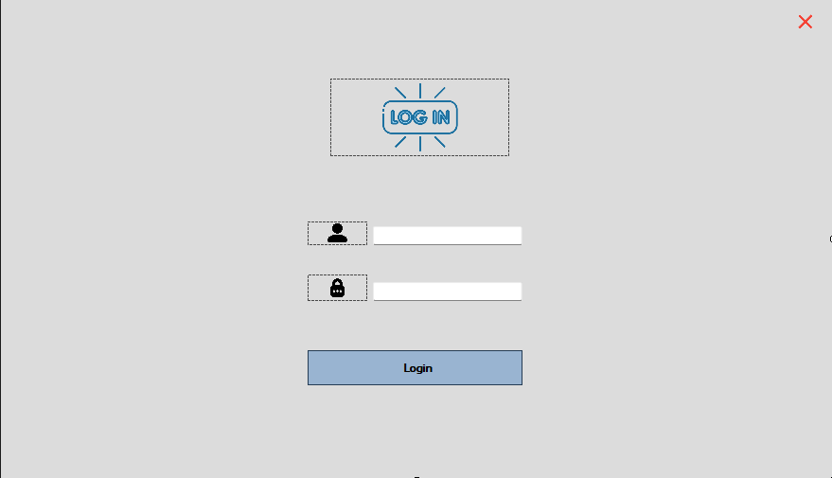

#Form1.cs

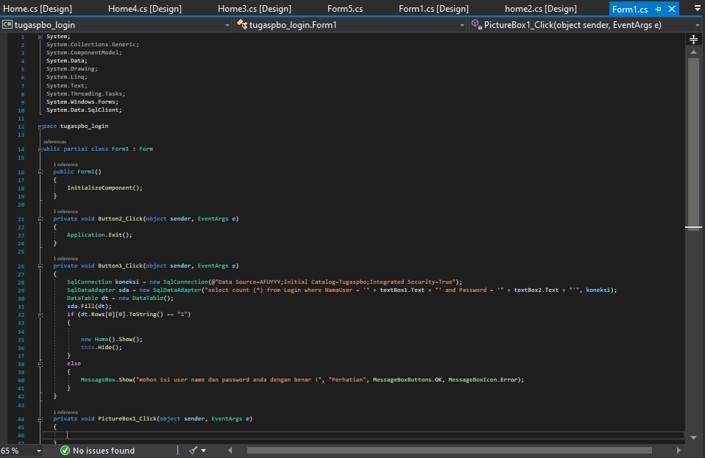

#Home.cs[Design]

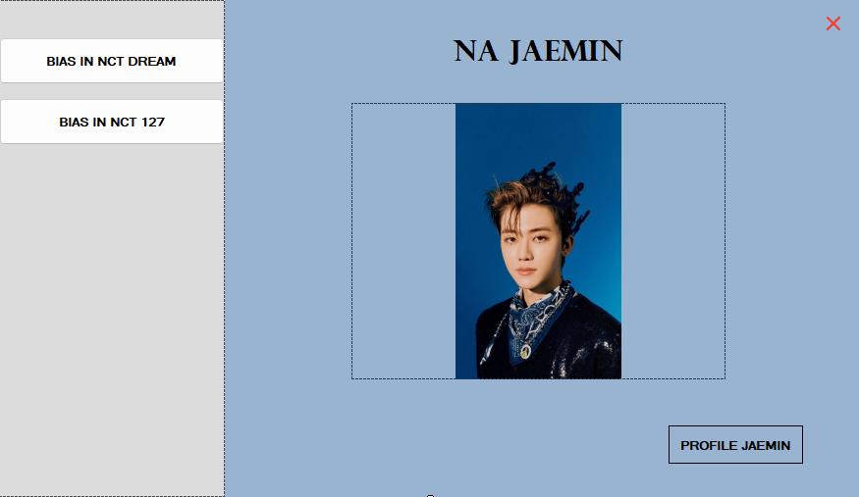

#Home.cs

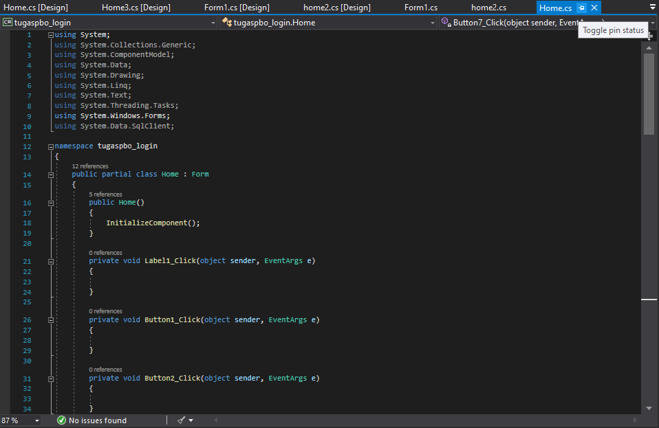

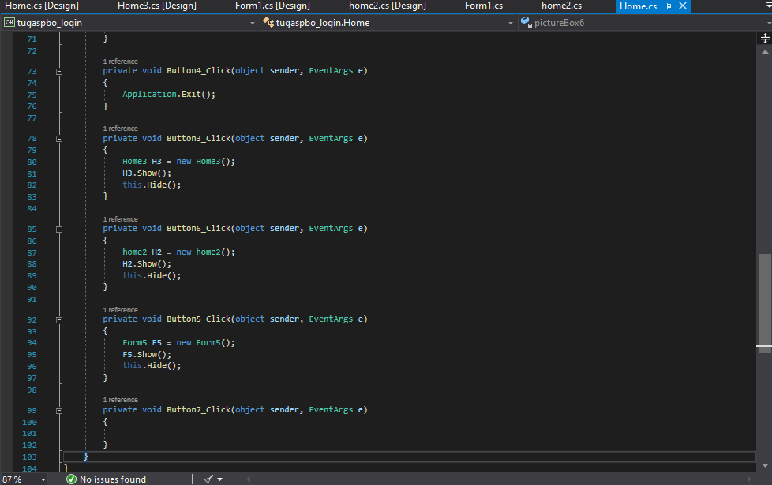

#home2.cs[Design]

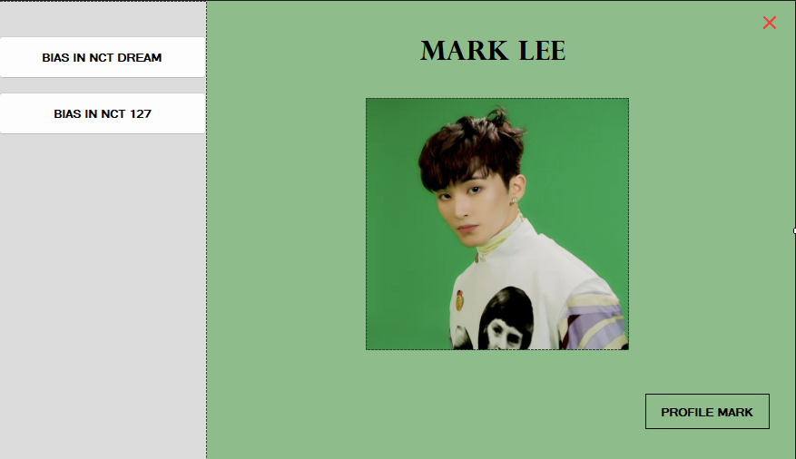

#home.cs

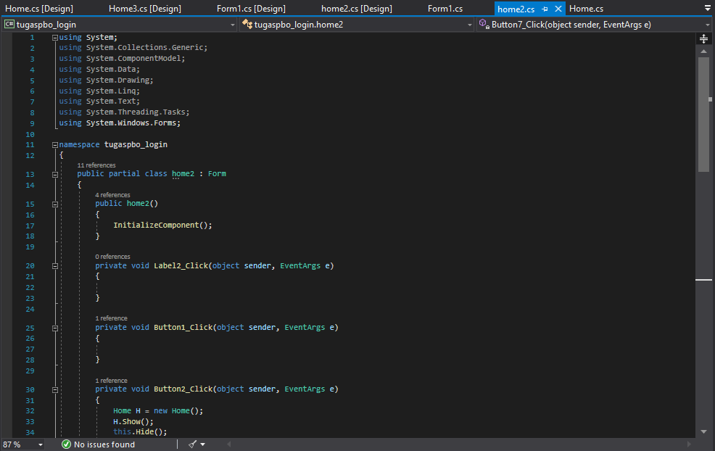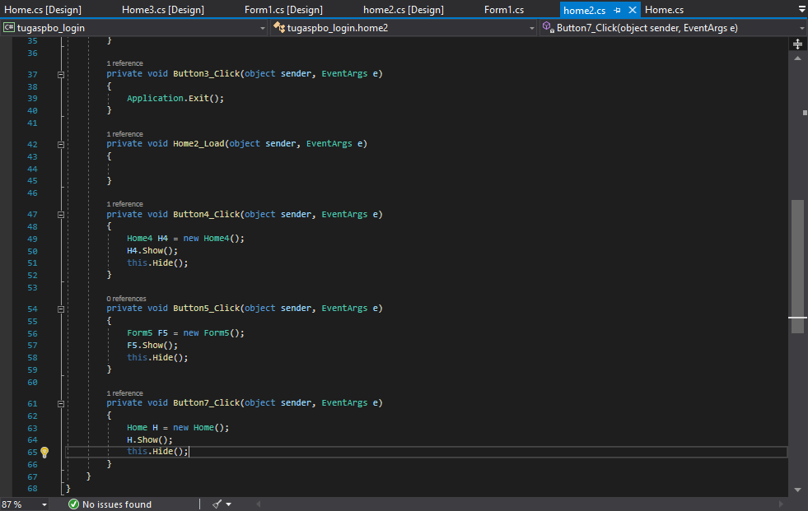

#Home3.cs[Design]

-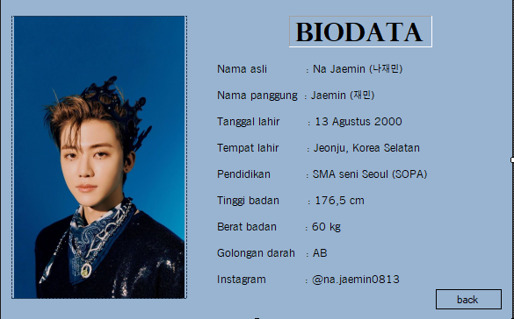

#Home3.cs

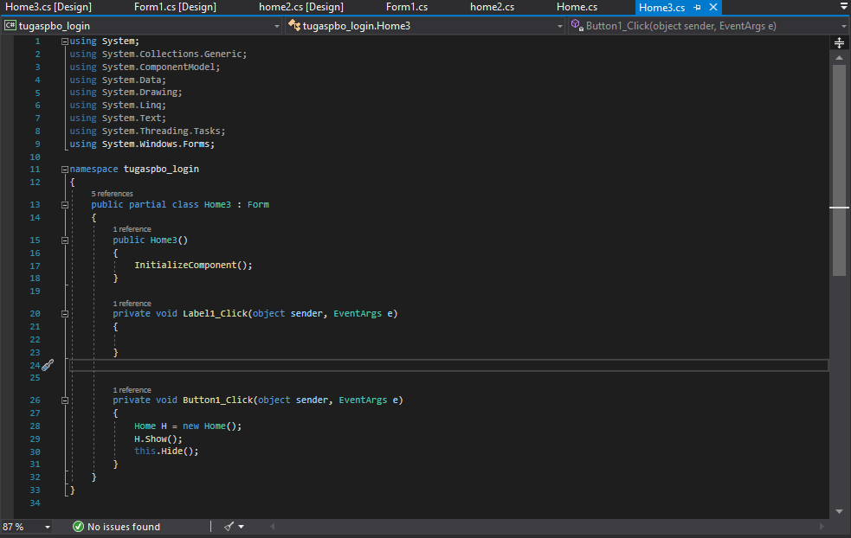

#Home4.cs[Design]

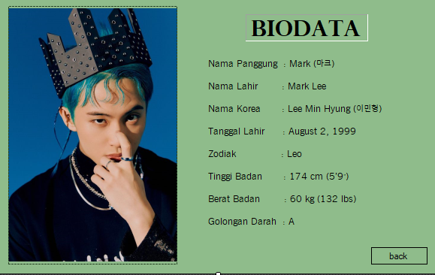

#Home4.cs

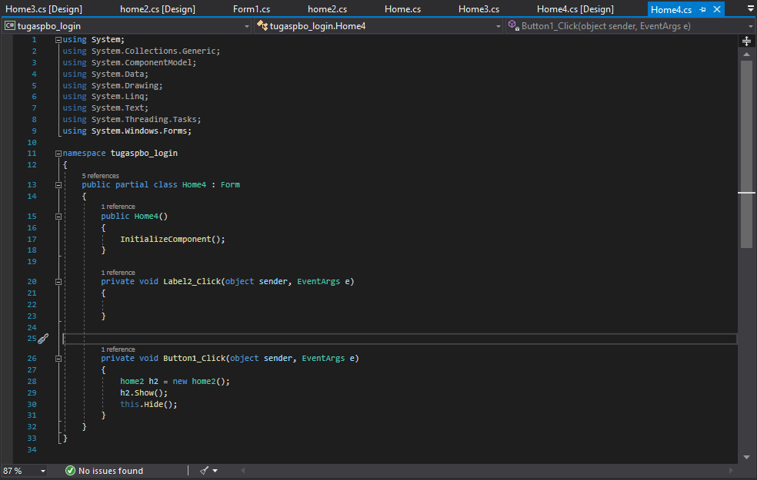

1. **Tugas Latihan 1-6**

#Form1.cs[Design]

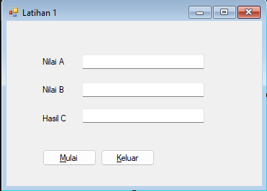

#Form1.cs

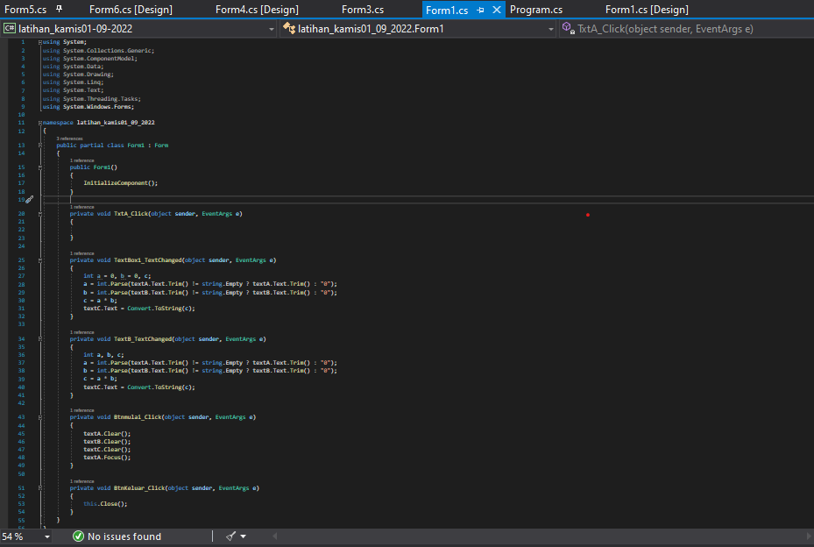

#Form2.cs[Design]

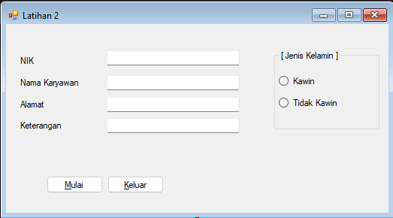

#Form2.cs

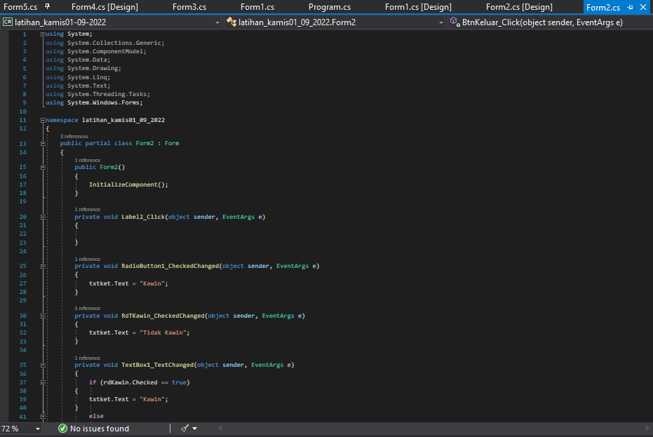

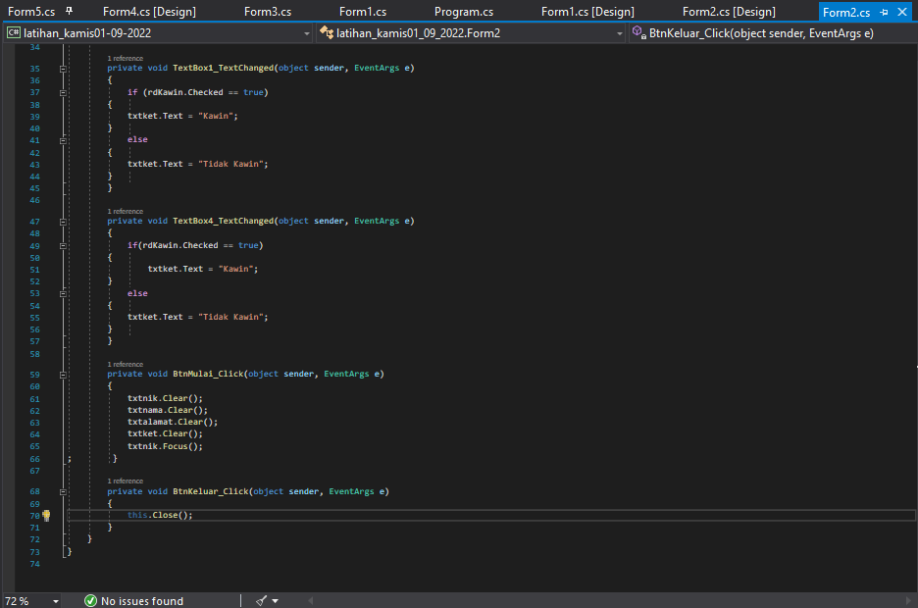

#Form3.cs[Design]

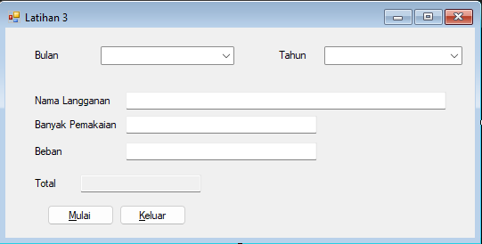

#Form3.cs

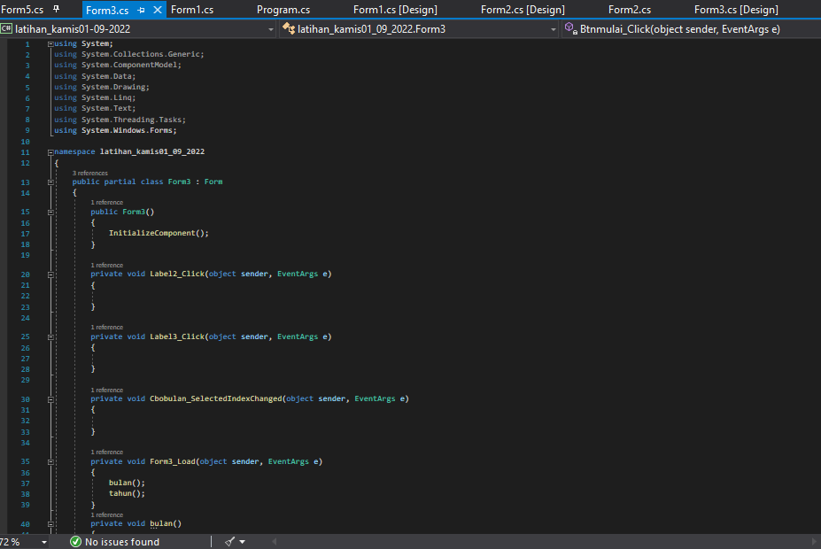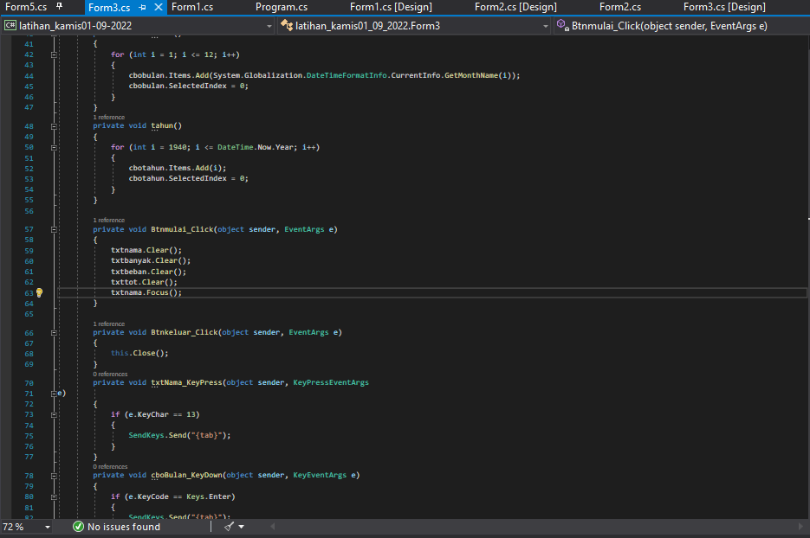

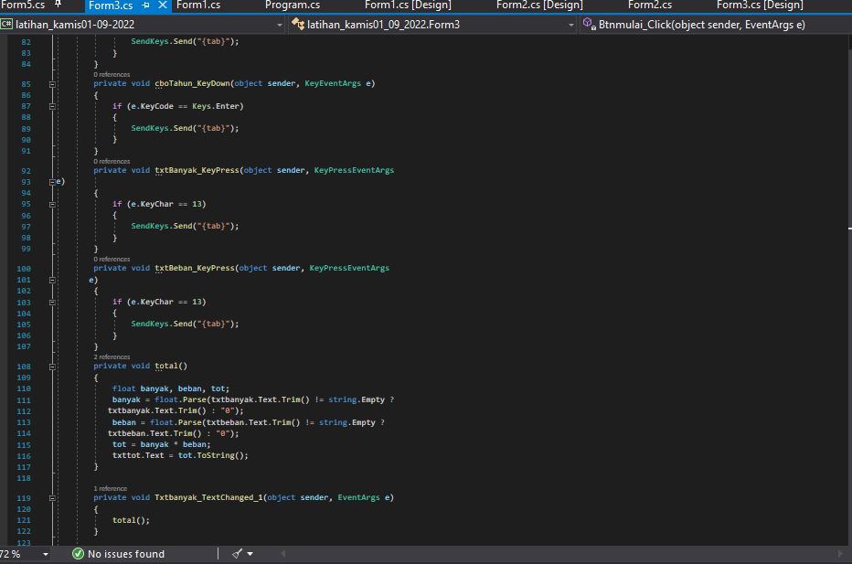

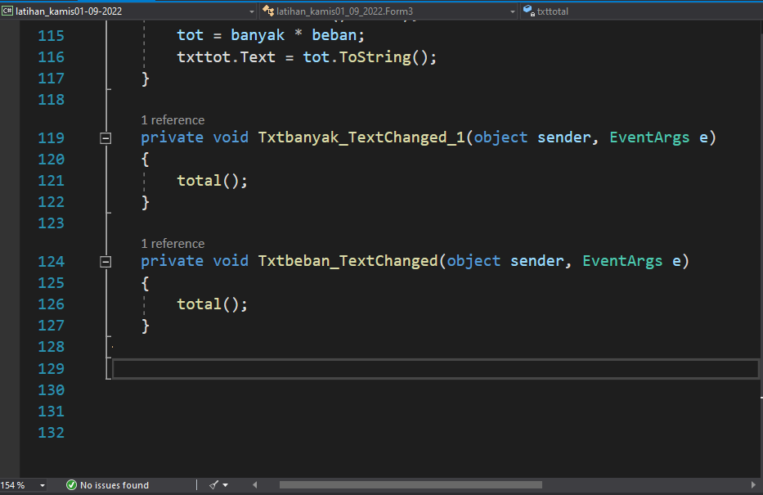

#Form4.cs[Design]

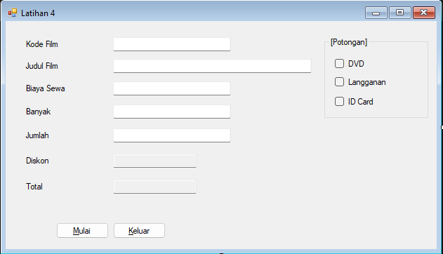

#Form4.cs

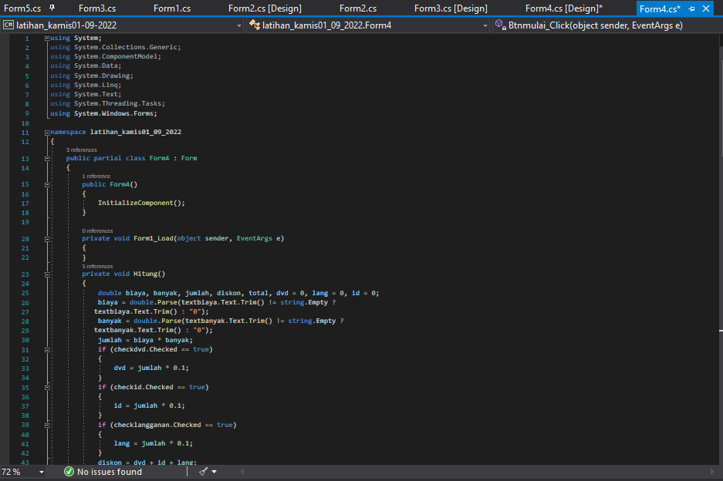

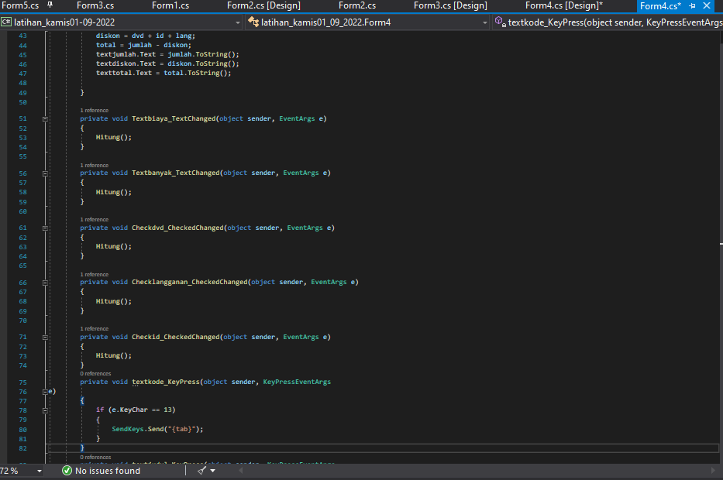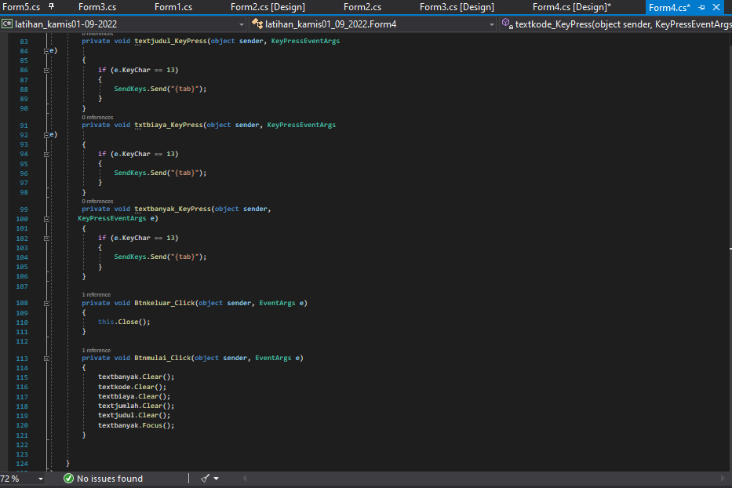

#Form5.cs[Design]

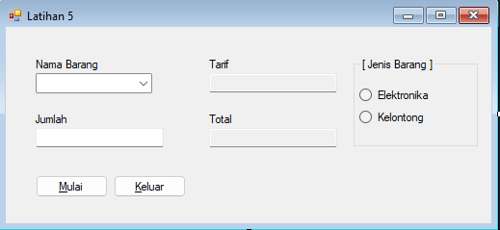

#Form5.cs

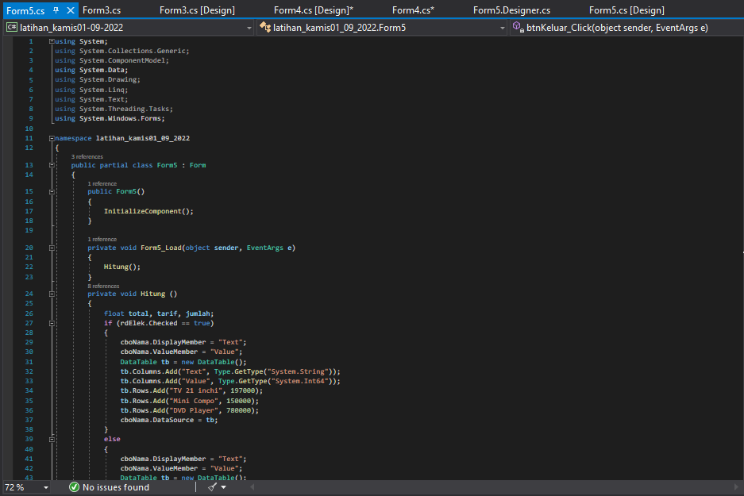

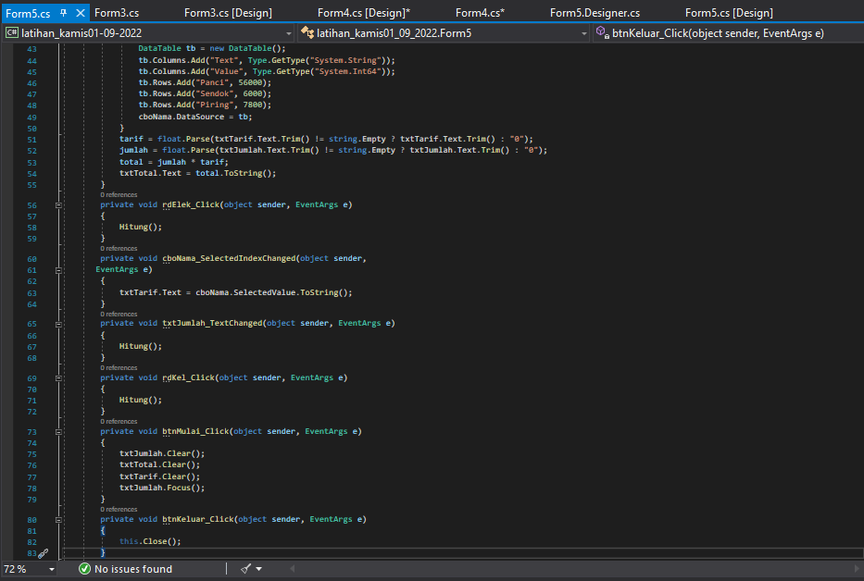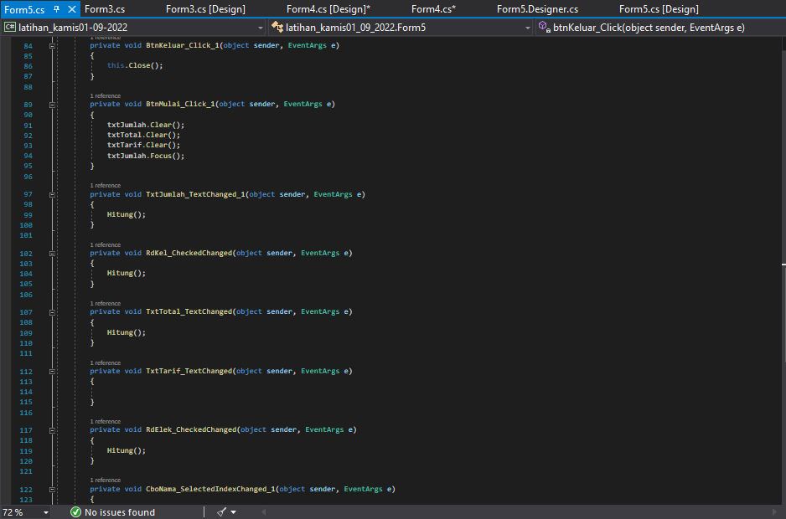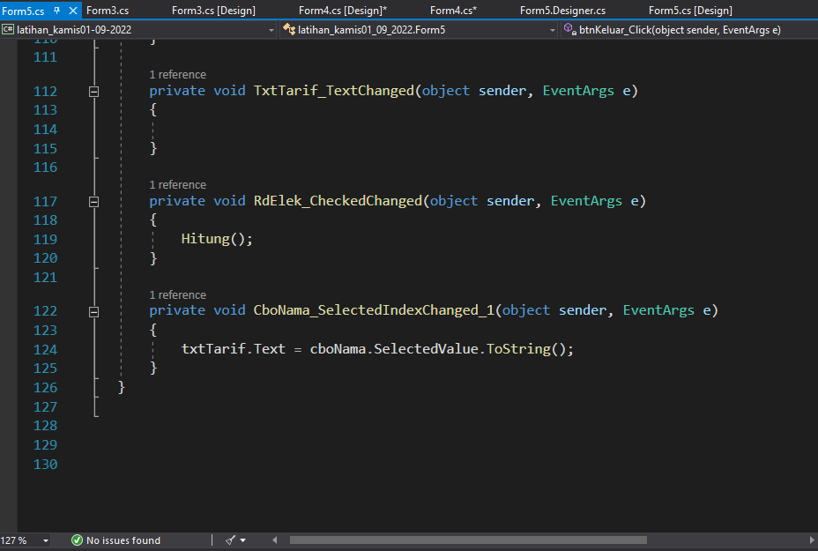

#Form6.cs[Design]

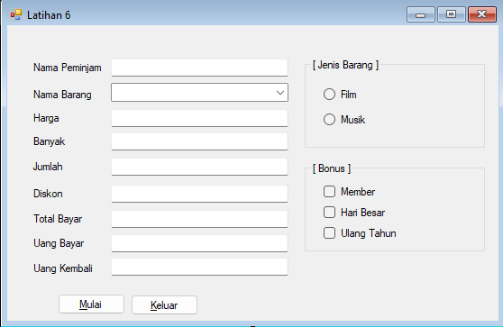

#Form6.cs

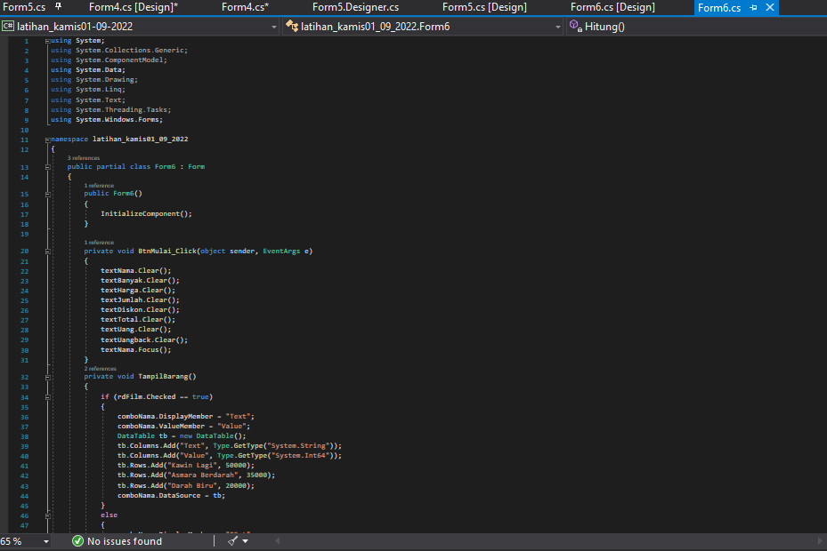

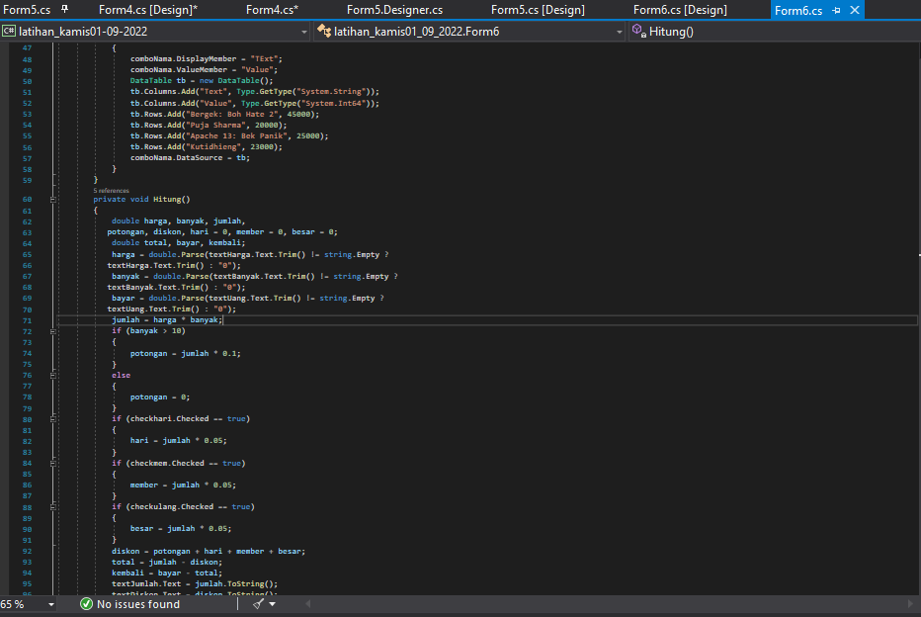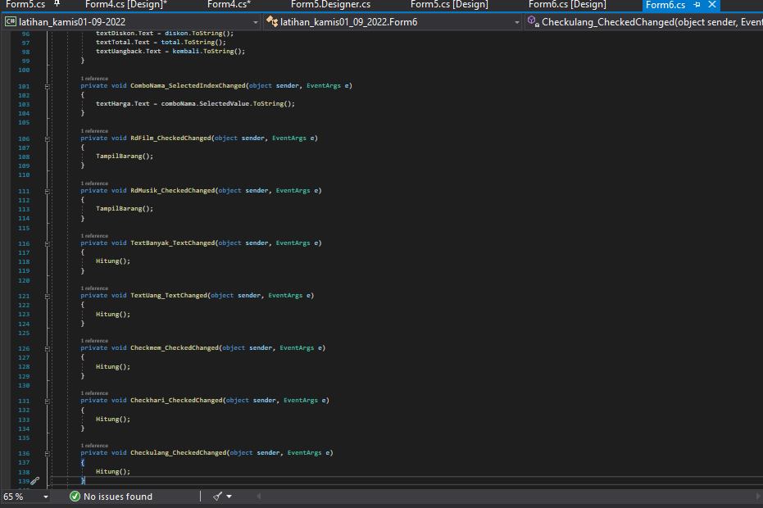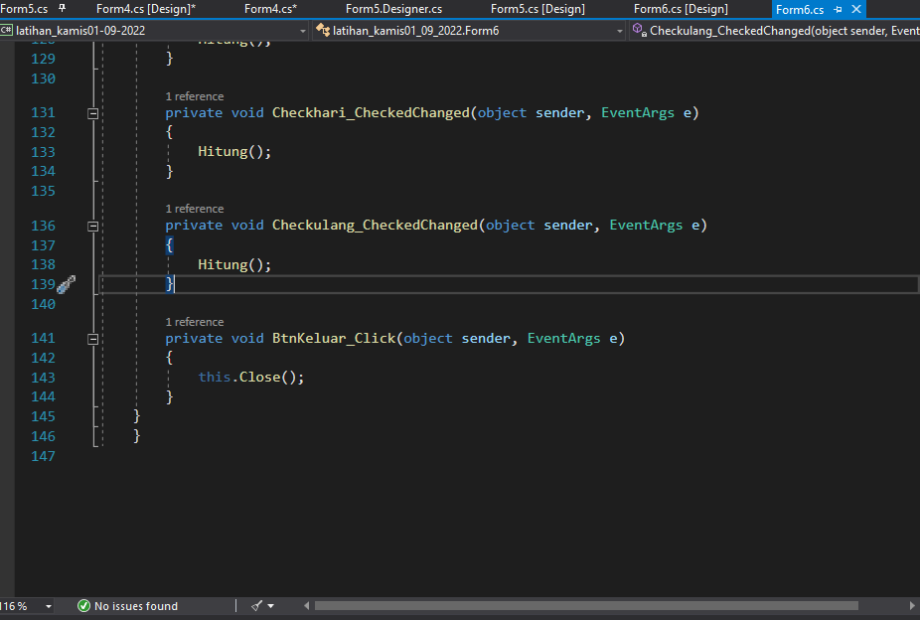

1. **Tugas BAB 8**

#table_fakultas

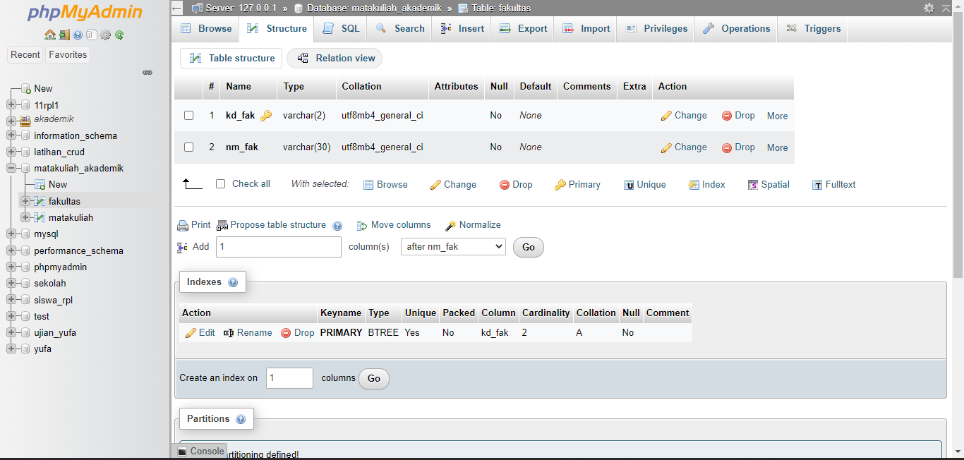

#Form1.cs[Design]

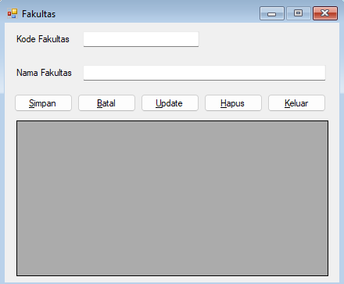

#Form1.cs

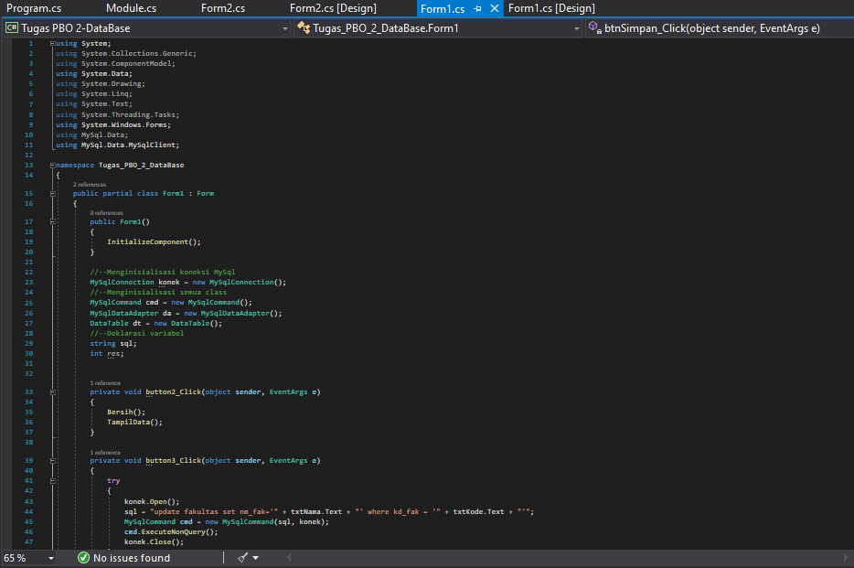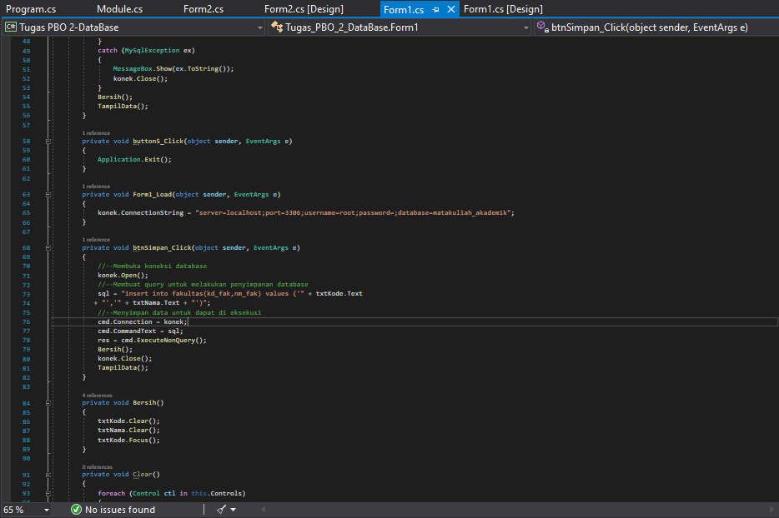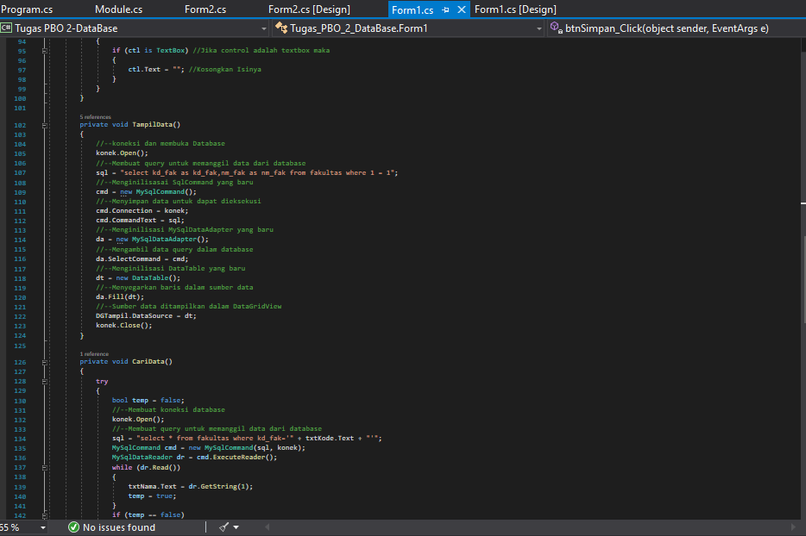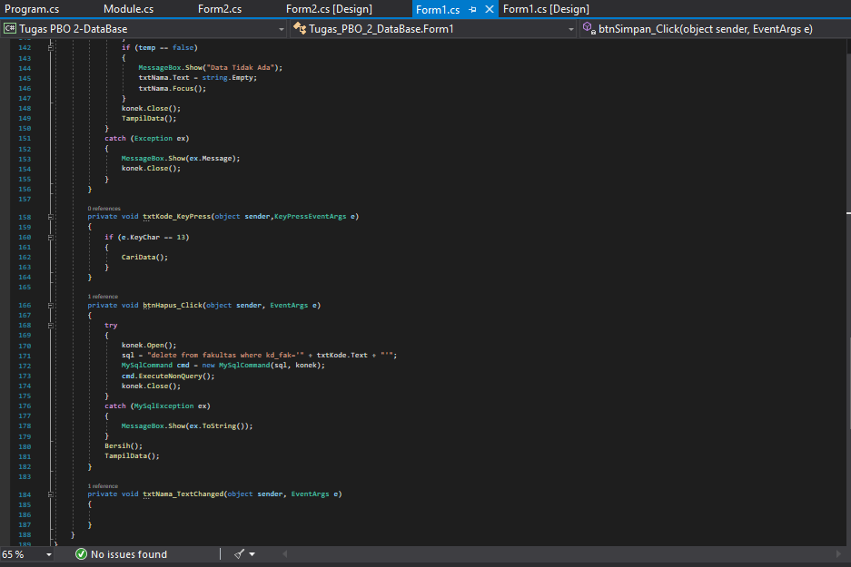

#table_matakuliah

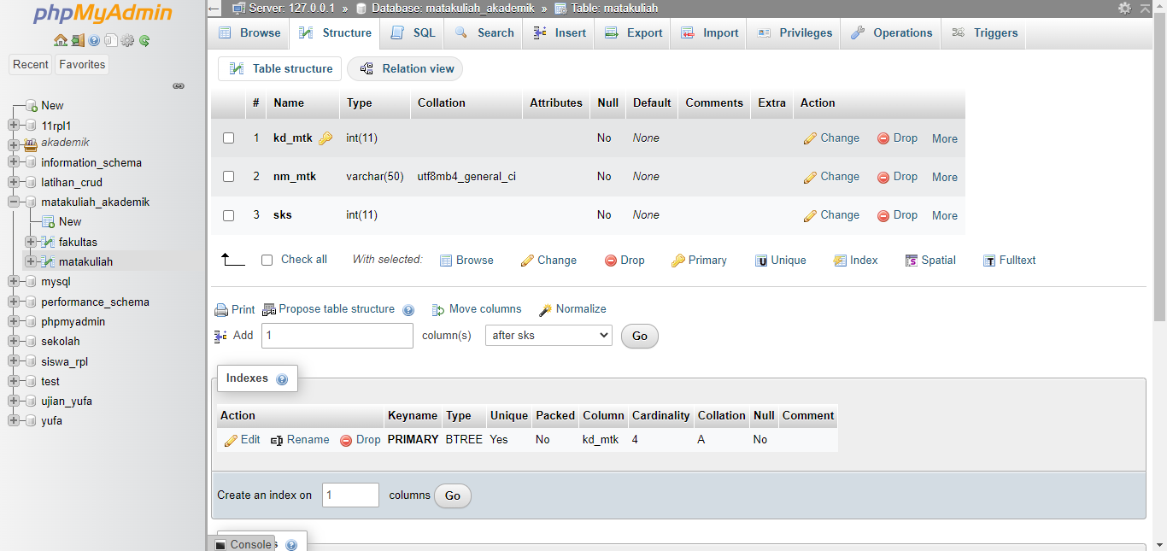

#Form2.cs[Design]

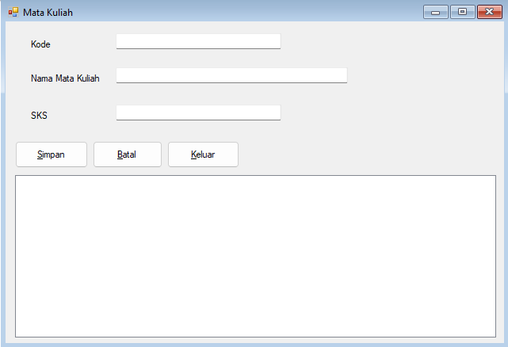

#Form2.cs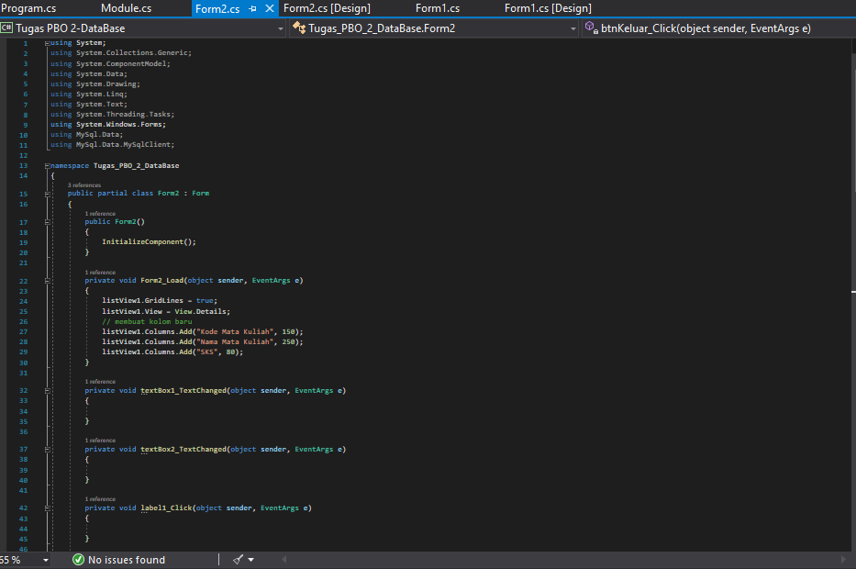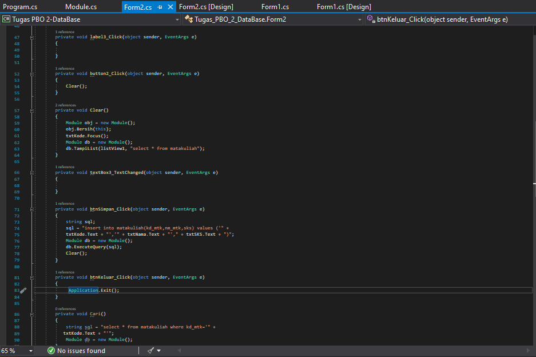

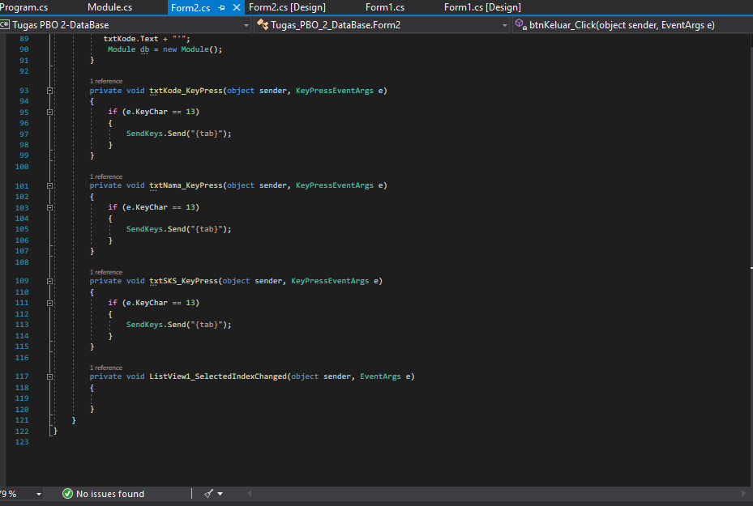

#Module.cs

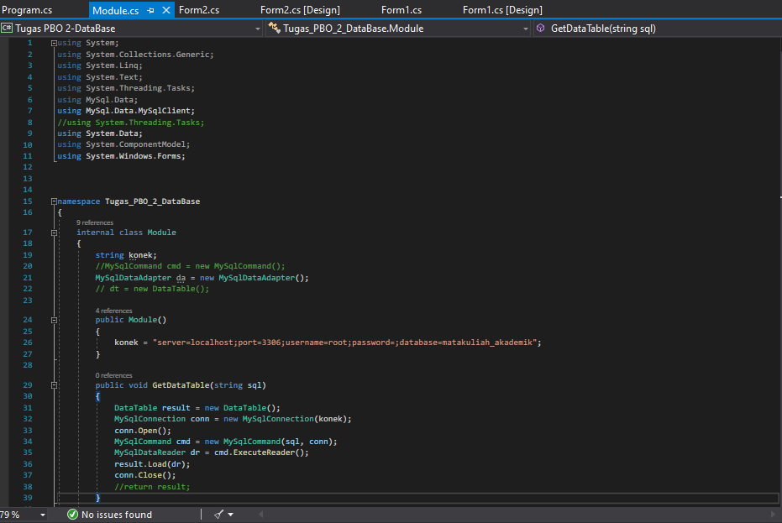

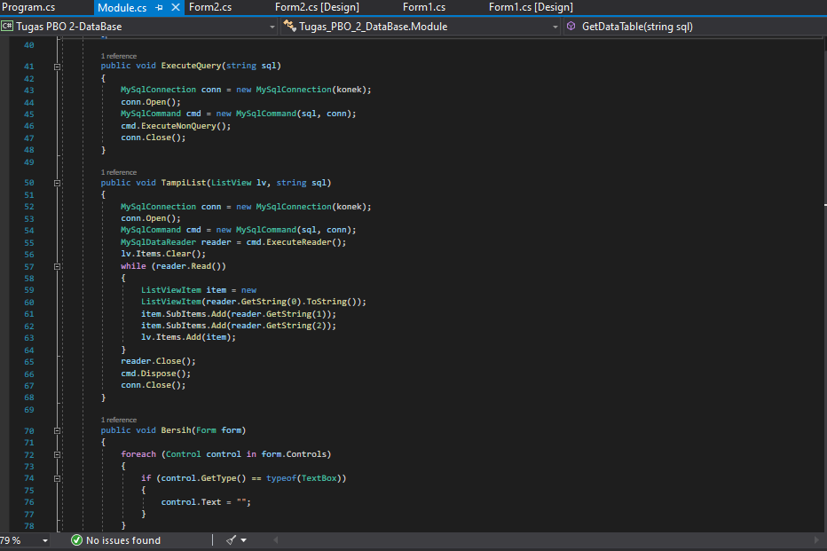

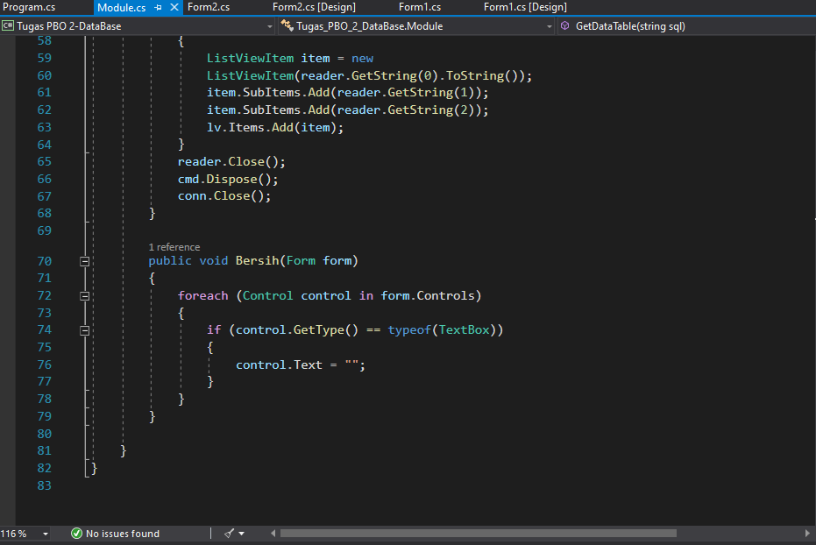

**Aplikasi Input Data Diri Siswa**

#table_siswa

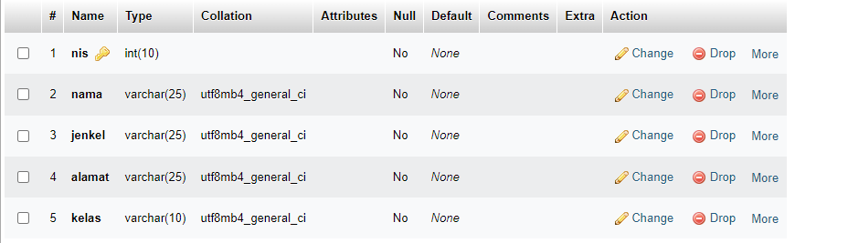

#Form1.cs[Design]

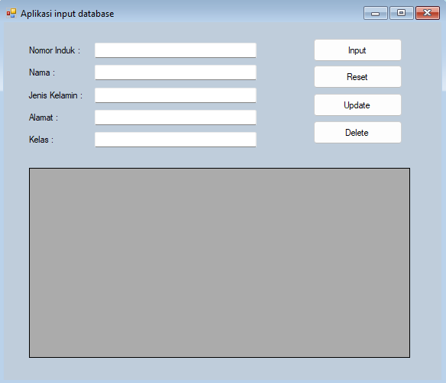

#Form1.cs

using System;

using System.Collections.Generic;

using System.ComponentModel;

using System.Data;

using System.Drawing;

using System.Linq;

using System.Text;

using System.Threading.Tasks;

using System.Windows.Forms;

using MySql.Data.MySqlClient;

namespace insert_database

{

public partial class Form1 : Form

{

string database = ("server = localhost; uid = root; database=sekolah; pwd='';");

public MySqlConnection koneksi;

public MySqlCommand cmd;

public MySqlDataAdapter adp;

public Form1()

{

InitializeComponent();

}

public void Query(string query)

{

koneksi = new MySqlConnection(database);

try

{

koneksi.Open();

cmd = new MySqlCommand(query, koneksi);

cmd.ExecuteNonQuery();

}

catch (Exception ali)

{

MessageBox.Show(ali.Message);

}

finally

{

koneksi.Close();

}

}

private void Button1_Click(object sender, EventArgs e)

{

Query("insert into siswa values('" + this.textBox1.Text +"','" + this.textBox2.Text + "','" + this.textBox3.Text +"','" + this.textBox4.Text + "','" + this.textBox5.Text + "')");

MessageBox.Show("Insert data berhasil");

baca();

}

private void Button2_Click(object sender, EventArgs e)

{

textBox1.Text = "";

textBox2.Text = "";

textBox3.Text = "";

textBox4.Text = "";

textBox5.Text = "";

}

public void query1()

{

try

{

koneksi = new MySqlConnection(database);

koneksi.Open();

string update = "UPDATE siswa SET nama='" + textBox2.Text +

"',jenkel ='" + textBox3.Text + "',alamat='" + textBox4.Text

+ "',kelas='" + textBox5.Text + "'WHERE nomor_induk='" +

textBox1.Text + "'";

cmd = new MySqlCommand(update, koneksi);

cmd.ExecuteNonQuery();

koneksi.Close();

MessageBox.Show("Update Sukses", "informasi",

MessageBoxButtons.OK);

}

catch (Exception ex)

{

MessageBox.Show(ex.Message);

}

}

private void Button4_Click(object sender, EventArgs e)

{

query1();

baca();

}

public void konek()

{

koneksi = new MySqlConnection(database);

koneksi.Open();

}

public void disconek()

{

koneksi = new MySqlConnection(database);

koneksi.Close();

}

public DataTable baca()

{

string sql = "select * from siswa";

DataTable dt = new DataTable();

try

{

konek();

cmd = new MySqlCommand(sql, koneksi);

adp = new MySqlDataAdapter(cmd);

cmd.ExecuteNonQuery();

adp.Fill(dt);

dataGridView1.DataSource = dt;

}

catch (Exception ali)

{

MessageBox.Show(ali.Message);

}

disconek();

return dt;

}

public void query2()

{

try

{

koneksi = new MySqlConnection(database);

koneksi.Open();

string del = "delete from siswa WHERE nomor_induk = '" + textBox1.Text + "'";

cmd = new MySqlCommand(del, koneksi);

cmd.ExecuteNonQuery();

koneksi.Close();

MessageBox.Show("Delete Sukses", "informasi",

MessageBoxButtons.OK);

}

catch (Exception ex)

{

MessageBox.Show(ex.Message);

}

}

private void Button3_Click(object sender, EventArgs e)

{

query2();

baca();

}

private void DataGridView1_CellContentClick(object sender, DataGridViewCellEventArgs e)

{

}

}

}

**Aplikasi Hotel Reception**

#Form1.cs[Design]

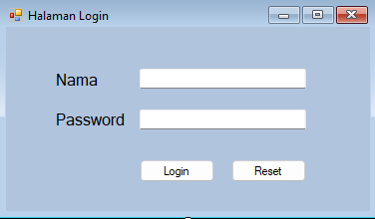

#Form1.cs

using System;

using System.Collections.Generic;

using System.ComponentModel;

using System.Data;

using System.Drawing;

using System.Linq;

using System.Text;

using System.Threading.Tasks;

using System.Windows.Forms;

using MySql.Data.MySqlClient;

namespace Tugas_Aplikasi_Hotel

{

public partial class Form1 : Form

{

public Form1()

{

InitializeComponent();

}

private void Button1_Click(object sender, EventArgs e)

{

try

{

MySqlConnection conn = new MySqlConnection(@"datasource=127.0.0.1;port=3306;SslMode=none;username=root;password=;database=pts;");

MySqlDataAdapter sda = new MySqlDataAdapter("select * from users where nis='" + nama.Text.Trim() + "'and password='" + pss.Text.Trim() + "'", conn);

DataTable dt = new DataTable();

sda.Fill(dt);

if (dt.Rows.Count == 1)

{

MySqlCommand cmd = new MySqlCommand("select * from users where nis='" + nama.Text.Trim() + "'and password='" + pss.Text.Trim() + "'", conn);

conn.Open();

cmd.ExecuteNonQuery();

MySqlDataReader reader;

reader = cmd.ExecuteReader();

while (reader.Read())

{

Form2 Form2 = new Form2();

this.Hide();

Form2.Show();

}

}

else

{

MessageBox.Show("mohon maaf sayangku password anda salah.");

}

}

catch (Exception x)

{

MessageBox.Show(x.ToString());

}

}

private void Button2_Click(object sender, EventArgs e)

{

nama.Text = "";

pss.Text = "";

}

}

}

#Form2.cs[Design]

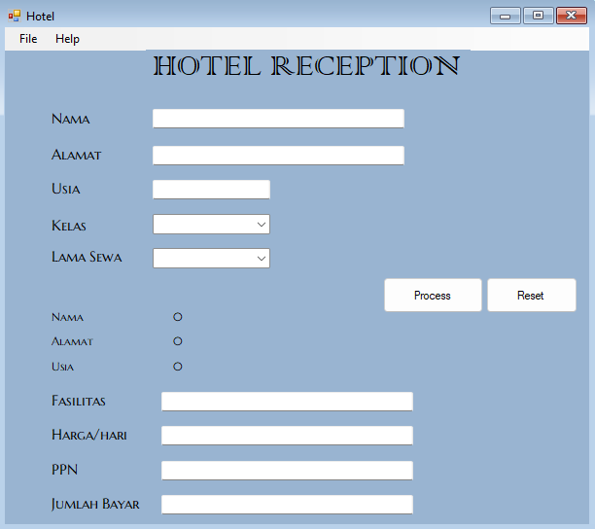

#Form2.cs

using System;

using System.Collections.Generic;

using System.ComponentModel;

using System.Data;

using System.Drawing;

using System.Linq;

using System.Text;

using System.Threading.Tasks;

using System.Windows.Forms;

namespace Tugas_Aplikasi_Hotel

{

public partial class Form2 : Form

{

public Form2()

{

InitializeComponent();

}

private void Button1_Click(object sender, EventArgs e)

{

string a, b, c, combo1, combo2;

int harga, ppn, total, lama;

a = textBox1.Text;

b = textBox2.Text;

c = textBox3.Text;

combo1 = comboBox1.Text;

combo2 = comboBox2.Text;

lama = Convert.ToInt16(combo2);

if (combo1.Equals("VIP"))

{

textBox4.Text = "Kamar Mewah,TV dan Hotspot";

harga = 700000;

ppn = 20000;

total = (harga * lama) + ppn;

label8.Text = a;

label9.Text = b;

label14.Text = c;

textBox5.Text = harga.ToString(); ;

textBox6.Text = ppn.ToString();

textBox7.Text = total.ToString();

}

else if (combo1.Equals("STANDART"))

{

textBox4.Text = "Kamar Mewah dan TV";

harga = 500000;

ppn = 20000;

total = (harga * lama) + ppn;

label8.Text = a;

label9.Text = b;

label14.Text = c;

textBox5.Text = harga.ToString(); ;

textBox6.Text = ppn.ToString();

textBox7.Text = total.ToString();

}

else if (combo1.Equals("HEMAT"))

{

textBox4.Text = "Kamar Mewah ";

harga = 300000;

ppn = 20000;

total = (harga * lama) + ppn;

label8.Text = a;

label9.Text = b;

label14.Text = c;

textBox5.Text = harga.ToString(); ;

textBox6.Text = ppn.ToString();

textBox7.Text = total.ToString();

}

}

private void Button2_Click(object sender, EventArgs e)

{

textBox1.Text = "";

textBox2.Text = "";

textBox3.Text = "";

textBox4.Text = "";

textBox5.Text = "";

textBox6.Text = "";

textBox7.Text = "";

label8.Text = "";

label9.Text = "";

label14.Text = "";

comboBox1.Text = "";

comboBox2.Text = "";

}

private void NewToolStripMenuItem_Click(object sender, EventArgs e)

{

textBox1.Text = "";

textBox2.Text = "";

textBox3.Text = "";

textBox4.Text = "";

textBox5.Text = "";

textBox6.Text = "";

textBox7.Text = "";

label12.Text = "";

label13.Text = "";

label14.Text = "";

}

private void ExitToolStripMenuItem_Click(object sender, EventArgs e)

{

Form1 f = new Form1();

f.Close();/*untuk mengklos form1*/

this.Close();/*untuk mengklos form hotelcs*/

}

private void HelpToolStripMenuItem_Click(object sender, EventArgs e)

{

Help tolong = new Help();

tolong.Show();

}

}

}

#Help.cs[Design]

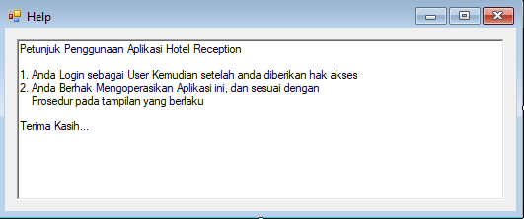

**Aplikasi Input Databuku**

#Form1.cs[Design]

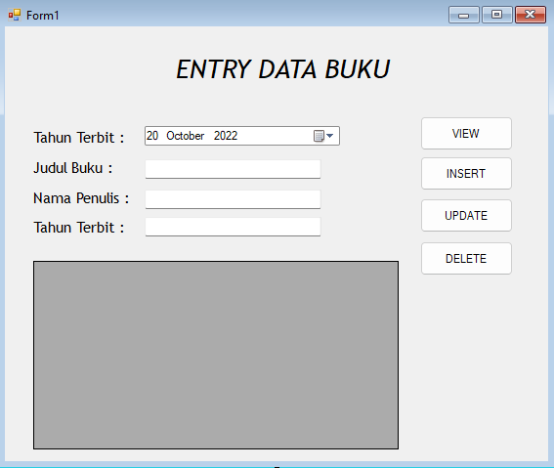

#Form1.cs

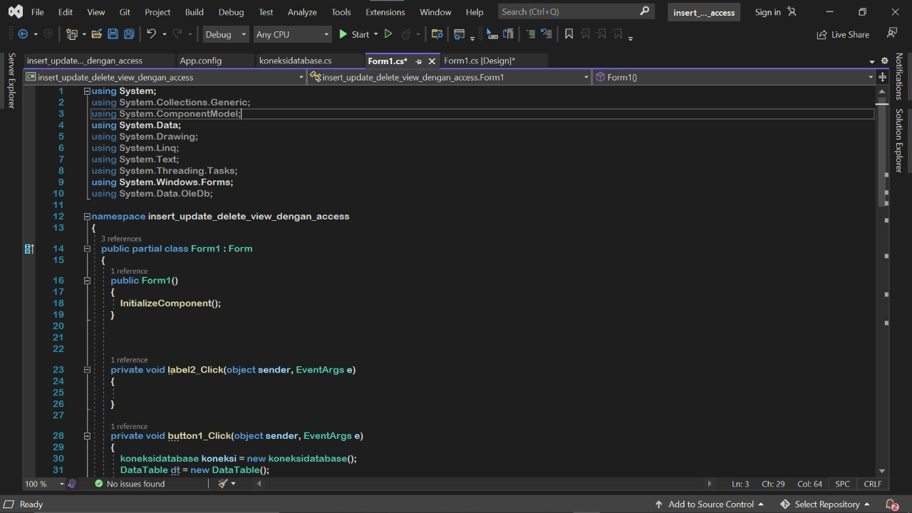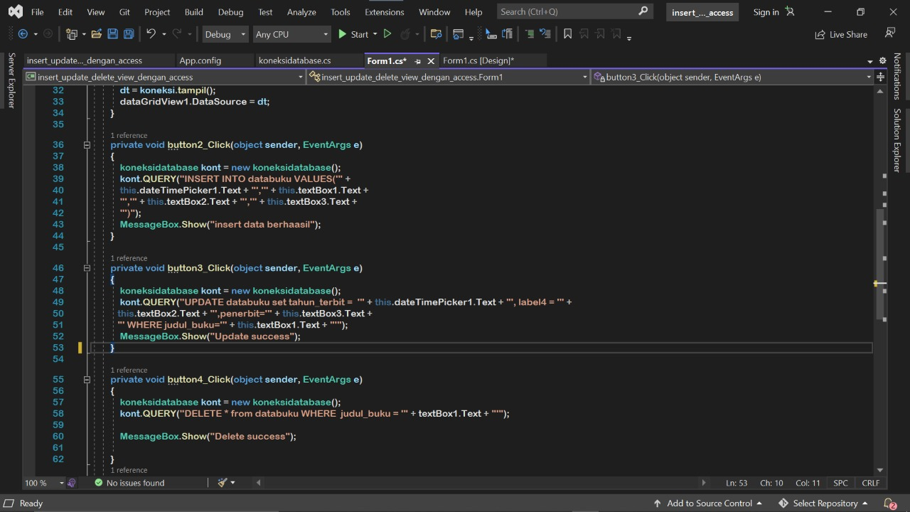

#koneksidatabase.cs

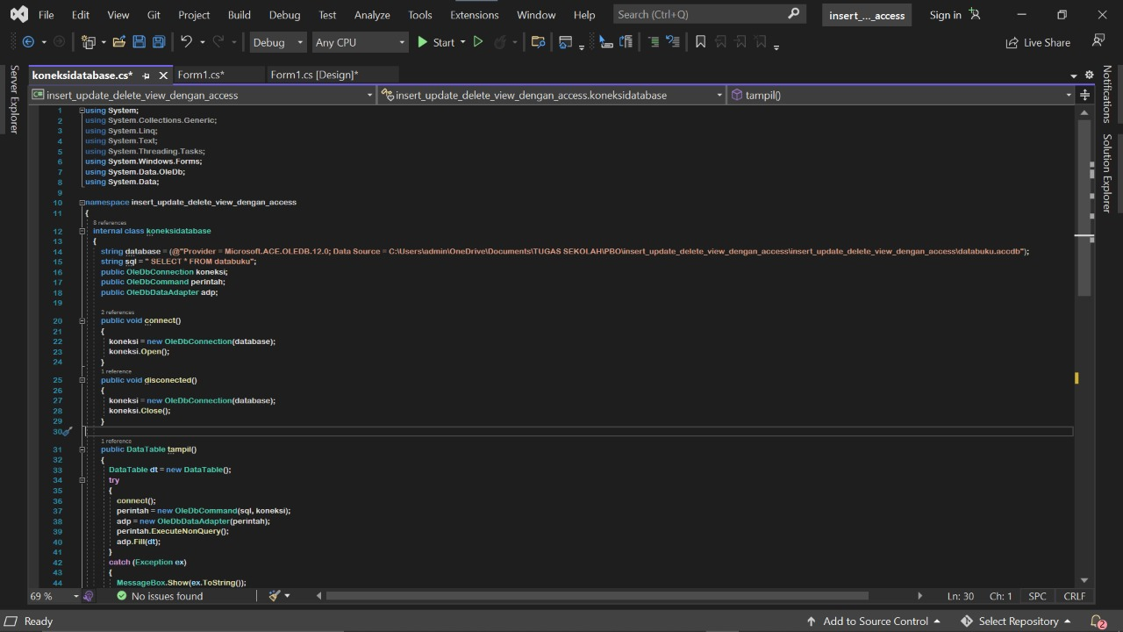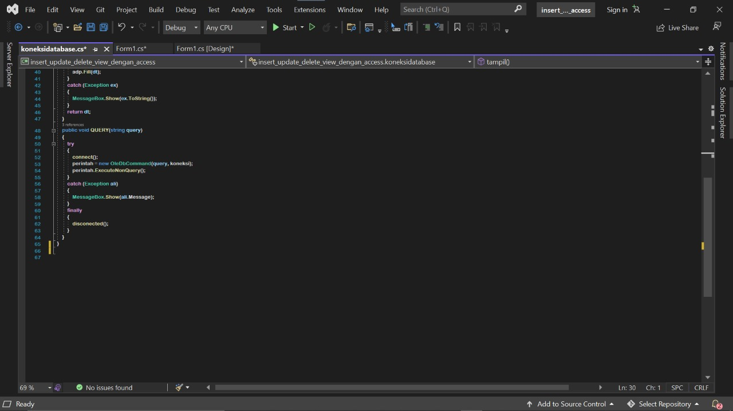

**Cara Menginstal Laporan Crystal untuk Visual Studio**

Masuk ke PC anda dengan izin administrator dan unduh file dari tautan di atas. setelah unduhan selesai, buka lokasi unduhan dan klik dua kali pada file yang diunduh.

Instalasi dimulai dengan membuka ritsleting penginstal

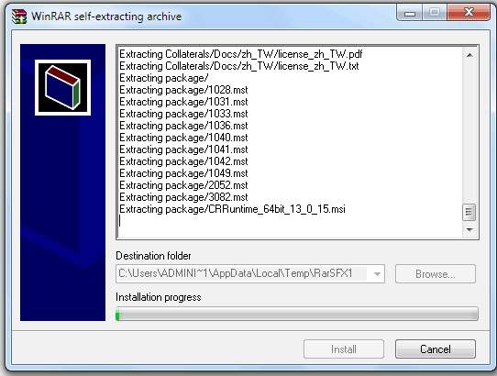

Instalasi Crystal Reports Unzip

Anda akan dibawa ke halaman pemilihan bahasa. Pilih bahasa yang benar dan klik ok

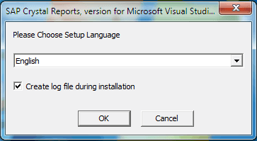

Instalasi Crystal Reports Pilih Bahasa

Anda akan melihat layar selamat datang seperti yang ditunjukkan di bawah ini. Klik Berikutnya untuk melanjutkan

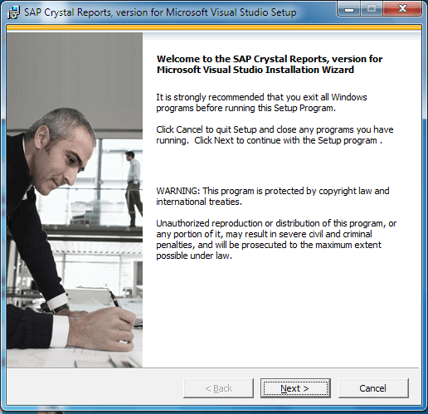

Layar Selamat Datang Instalasi Crystal Report

Ini akan membawa Anda ke perjanjian Lisensi. Pilih I Accept the license agreement dan klik next

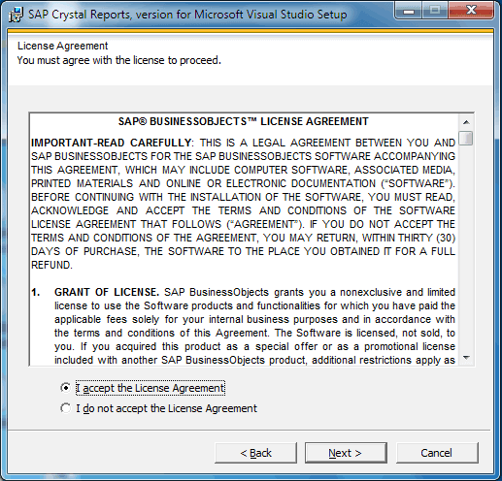

Perjanjian Lisensi Instalasi Crystal Report

Ini akan membawa Anda untuk memulai layar instalasi. Klik Berikutnya untuk Lanjutkan

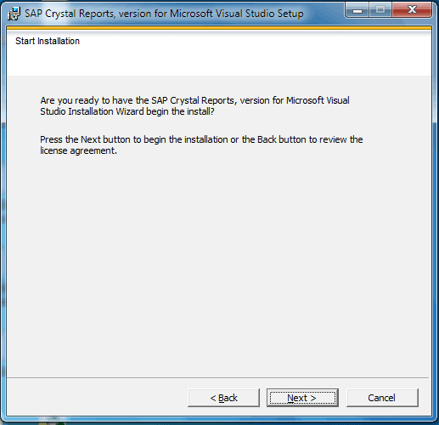

Instalasi Crystal Report Mulai Instalasi

Instalasi dimulai dan akan memakan waktu beberapa menit untuk menyelesaikannya. Pada akhirnya, Anda melihat layar berikut. Jika Anda ingin menginstal runtime, pilih Ya, Instal runtime 64-bit (atau 32 bit tergantung pada PC Anda). Klik Selesai

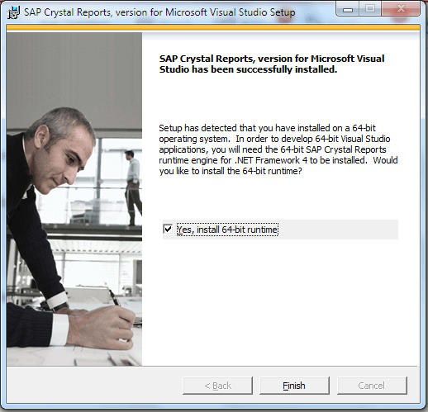

Instalasi Laporan Kristal Selesai

Jika Anda memilih Instal runtime 64-bit, maka penginstalan runtime akan dimulai dan perlu beberapa waktu untuk menyelesaikannya.